**San Francisco Airbnb Listing and Neighbourhood Venue Analysis**

Jayden Clark

26/12/2020

1. **Introduction**

San Francisco has been a popular city since its inception and has been the beneficiary of numerous economic booms from the gold and silver rushes, Central Pacific Railroad, dot com boom number one and dot com boom two. Because of these booms, San Francisco has had a high cost of living and with that, a high cost of travel. With the invention of Airbnb, travel anywhere has been made more efficient, comfortable and affordable and with its headquarters being located in San Francisco, it’s not unusual that the number of listings in San Francisco is high. San Francisco’s high cost of living and geographic location also allow it to boast a large number of amenities from bars and restaurants to scenic trails and parks.

* 1. **Problem**

When planning a trip to a new location, one must rely on research and word-to-mouth experience in order to determine where in that location they are going to stay and how much they are willing to pay. When determining this, two of the most important variables include access to amenities and the cost. Travellers often prioritise one of these variables over the other and this can diminish the experience. An analysis comparing the average cost of accommodation to the amount of venues in a neighbourhood can better equip travellers to make accurate accommodation decisions according to their budget and taste. San Francisco Airbnb prices vary from neighbourhood to neighbourhood and an unfamiliar traveller may find it difficult to find accommodation that maximises their experience.

* 1. **Interest**

Analysis of neighbourhood Airbnb cost and venue information such as the number of venues and most common venues can be utilised by travellers in order to determine their ideal location and experience. Airbnb and those that list on Airbnb can use the current correlations between cost and venue amount within a neighbourhood to improve customer experience and market share.

1. **Data**
   1. **Data Sources**

Airbnb listings for a given location as well as the corresponding neighbourhood boundaries in the form of a geo.json file can be found at <http://insideairbnb.com/get-the-data.html> .

San Francisco has 6998 total listings which include entire homes, private rooms and shared rooms.

* 1. **Cleaning and Feature Selection**

The relevant dataset was created by taking the following columns from the original dataset: neighbourhood, room-type, latitude, longitude, price. The dataset was then grouped by the neighbourhood and room-type mean in order to display the average price of each room type in each neighbourhood. Separate data frames were then created for the average price for all three room-types for each of the 36 neighbourhoods and subsequently, the average latitude and longitude of each listing which was used as the neighbourhood centroids, as well as the average price of each room-type per neighbourhood.

1. **Methodology**

Geopy’s “Nominatim” was used to pull the latitude and longitude of San Francisco before mapping the latitude and longitude of each neighbourhood from the “neighbourhood” data frame using python’s Folium package. Even though some markers are on the outskirts of their respective neighbourhood, this is intentional as the goal of this study is to analyse the amount and types of venues within a certain radius of neighbourhood Airbnb listings, therefore the average coordinates in each neighbourhood suffices.

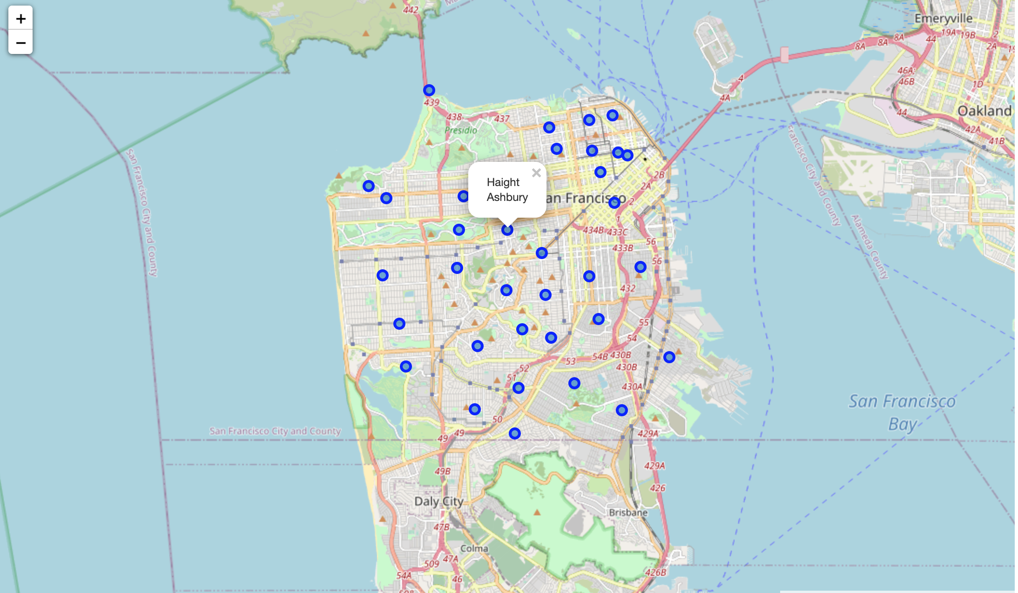

Fig 1. Map of San Francisco with neighbourhoods.

Venue information including the venue name, latitude, longitude and venue category was pulled using the Foursquare API with a limit of 100 venues and a radius of 500m from each neighbourhood marker. The number of venues per neighbourhood were then counted and plotted for analysis.

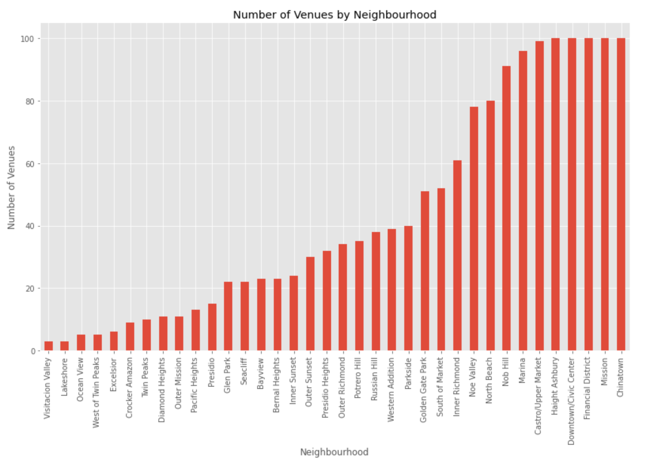

Fig 2. Number of venues per neighbourhood bar graph.

Correlation between the number of venues in each neighbourhood and the average Airbnb listing price was analysed. Correlation between these two features is 0.401907 which is substantial and is visible in figure 3 below.

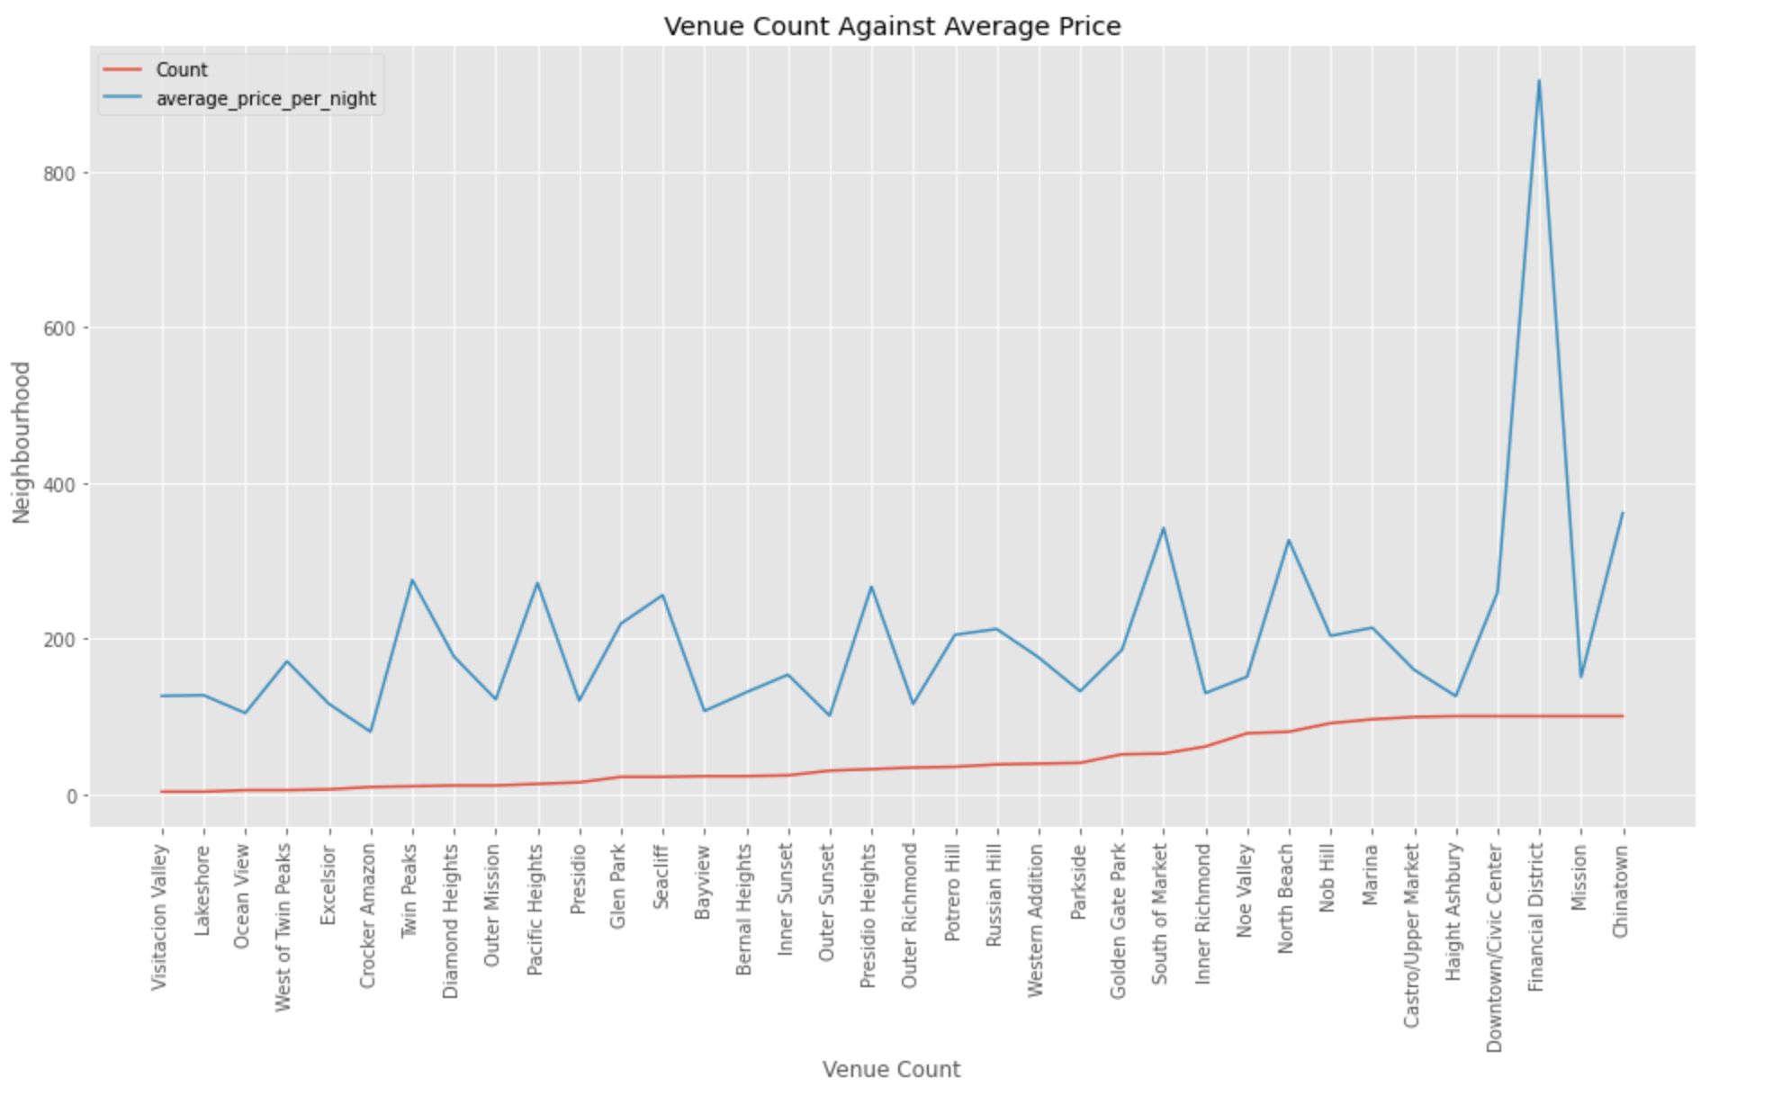

Fig 3. Number of venues against average Airbnb listing price line graph.

The same analysis is applied to the different room types separately. Note that analysis was done with neighbourhoods that featured all three room-types as listings. The number of neighbourhoods that satisfied this was 21 as opposed to the 36 neighbourhoods in total. Correlation was consistent for “Entire home/apt” and “Private room” with 0.451686 and 0.349983 respectively, reinforcing the 0.401907 correlation of the average of all three. Correlation for shared room was close to zero at -0.000990.

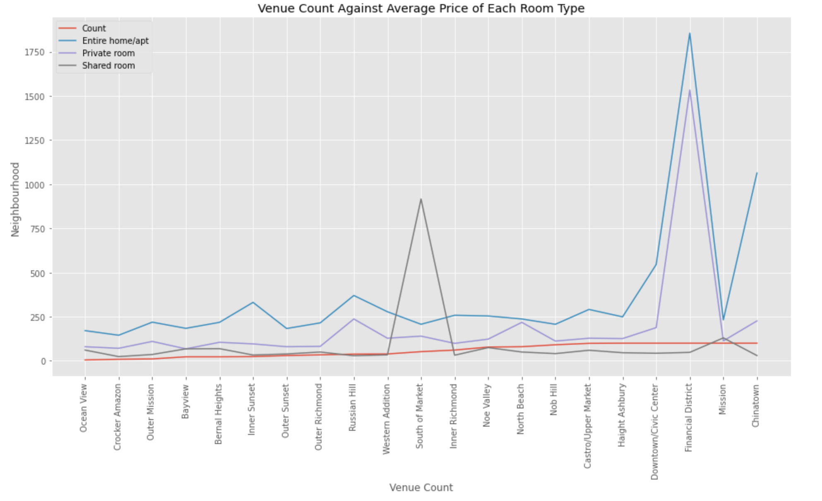

Fig 4. Number of venues against average Airbnb listing for each room-type line graph.

Before machine learning is applied, the 5 most common venues in each neighbourhood was acquired from Foursquare and added to a data frame. A plot of the number of first most common venue types was created for analysis and is displayed in figure 5.

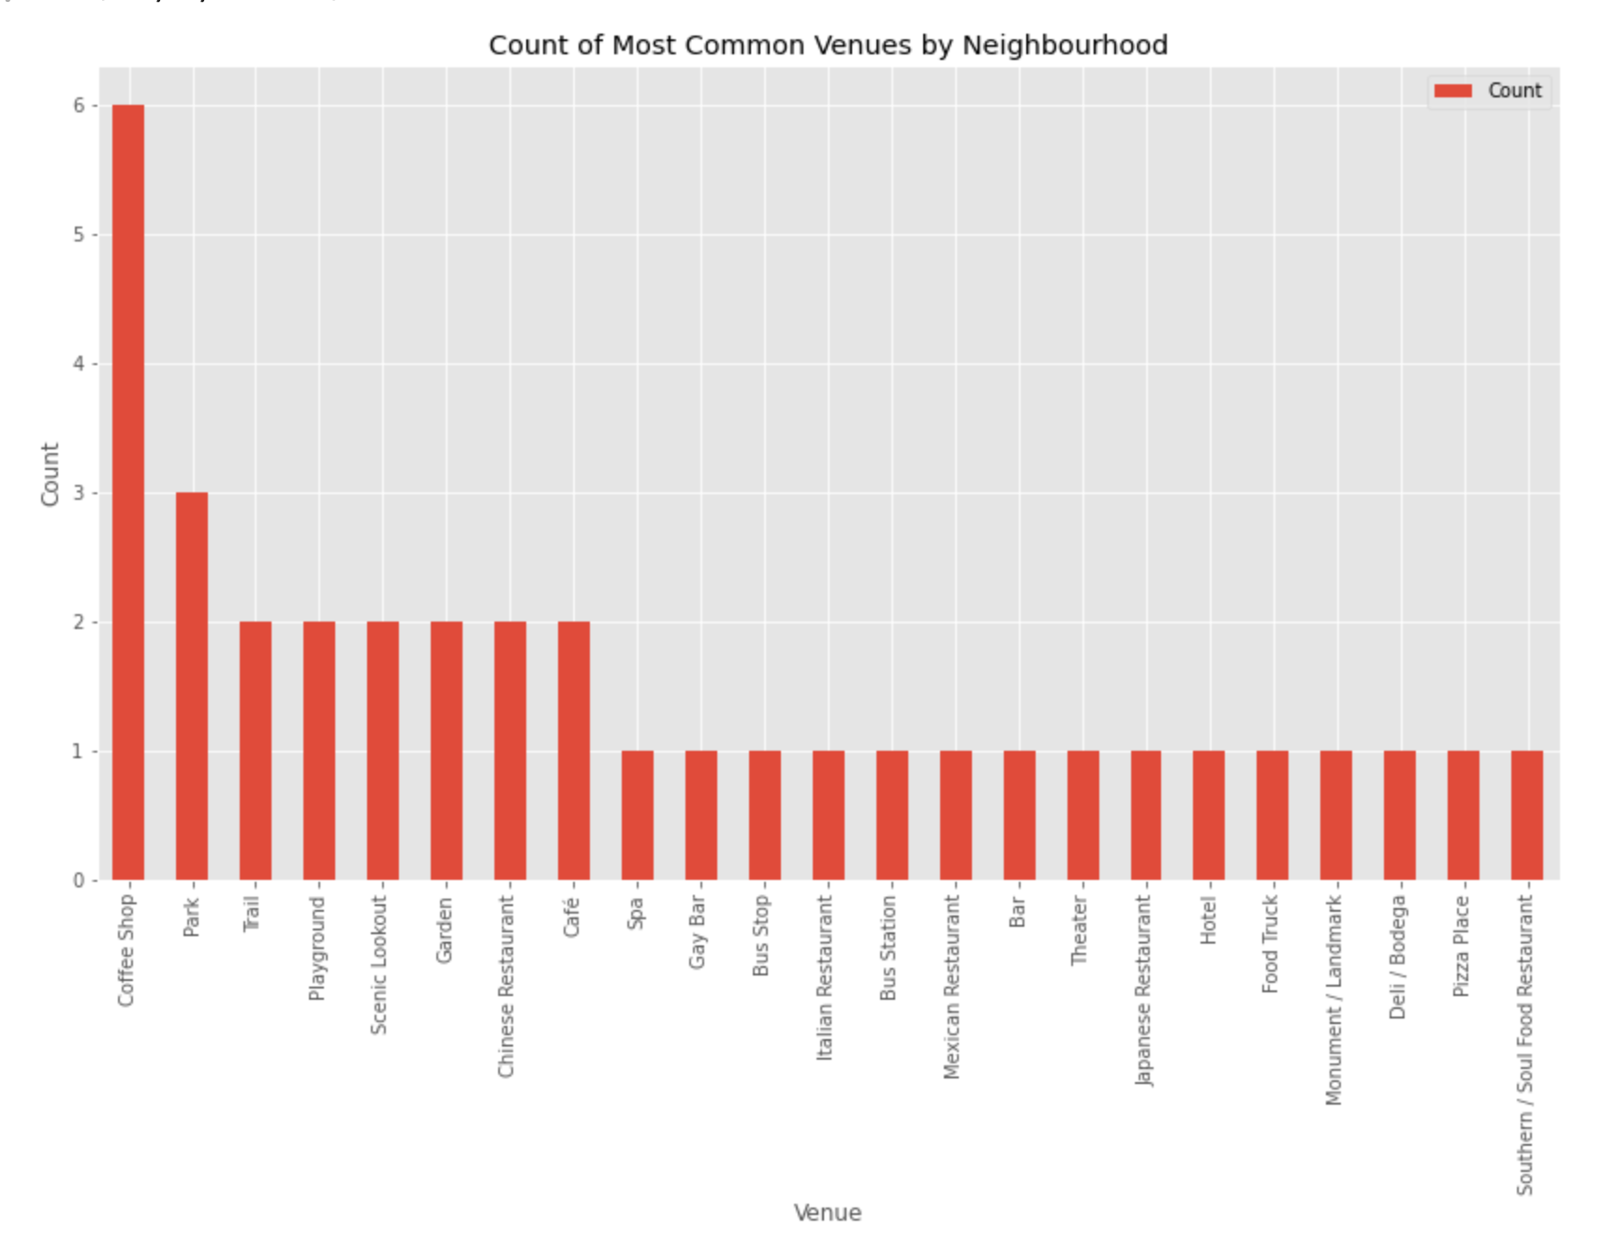

Fig 5. Recurring most common venues bar graph.

Coffee shops appeared 6 times as the most common, followed by parks at 3 and trail, playground and scenic lookout all at 2.

As shown in figure 5, neighbourhoods in San Francisco share many common popular venue categories and therefore, the K-means algorithm is the most suitable for clustering.

K=6 was selected in the following analysis as shown by the elbow method.

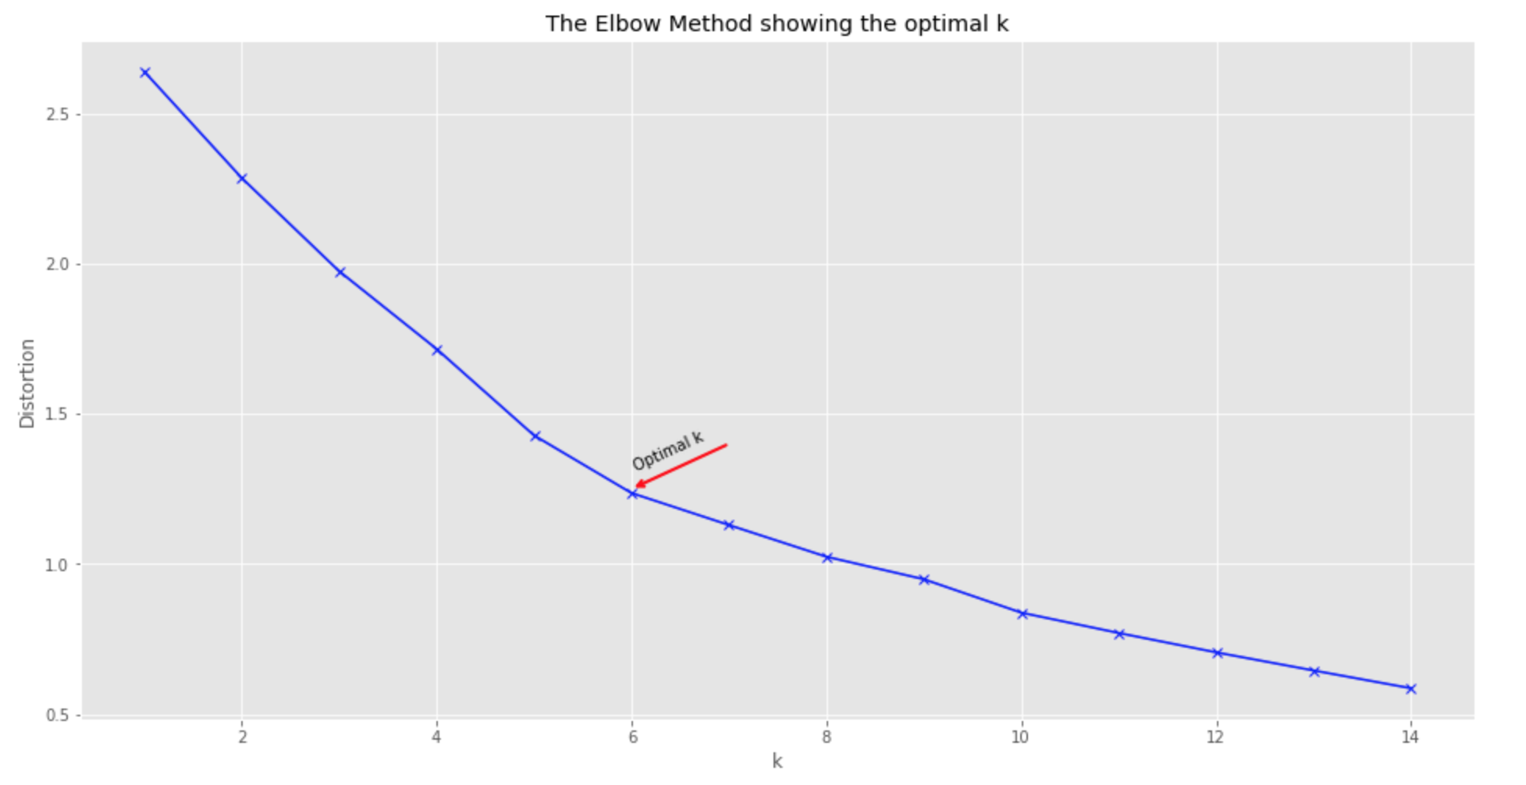

Fig 6. K-means elbow.

Once clustered, label names were determined by inserting the label numbers into the data frame with the most common venues and printing each cluster label separately like so:

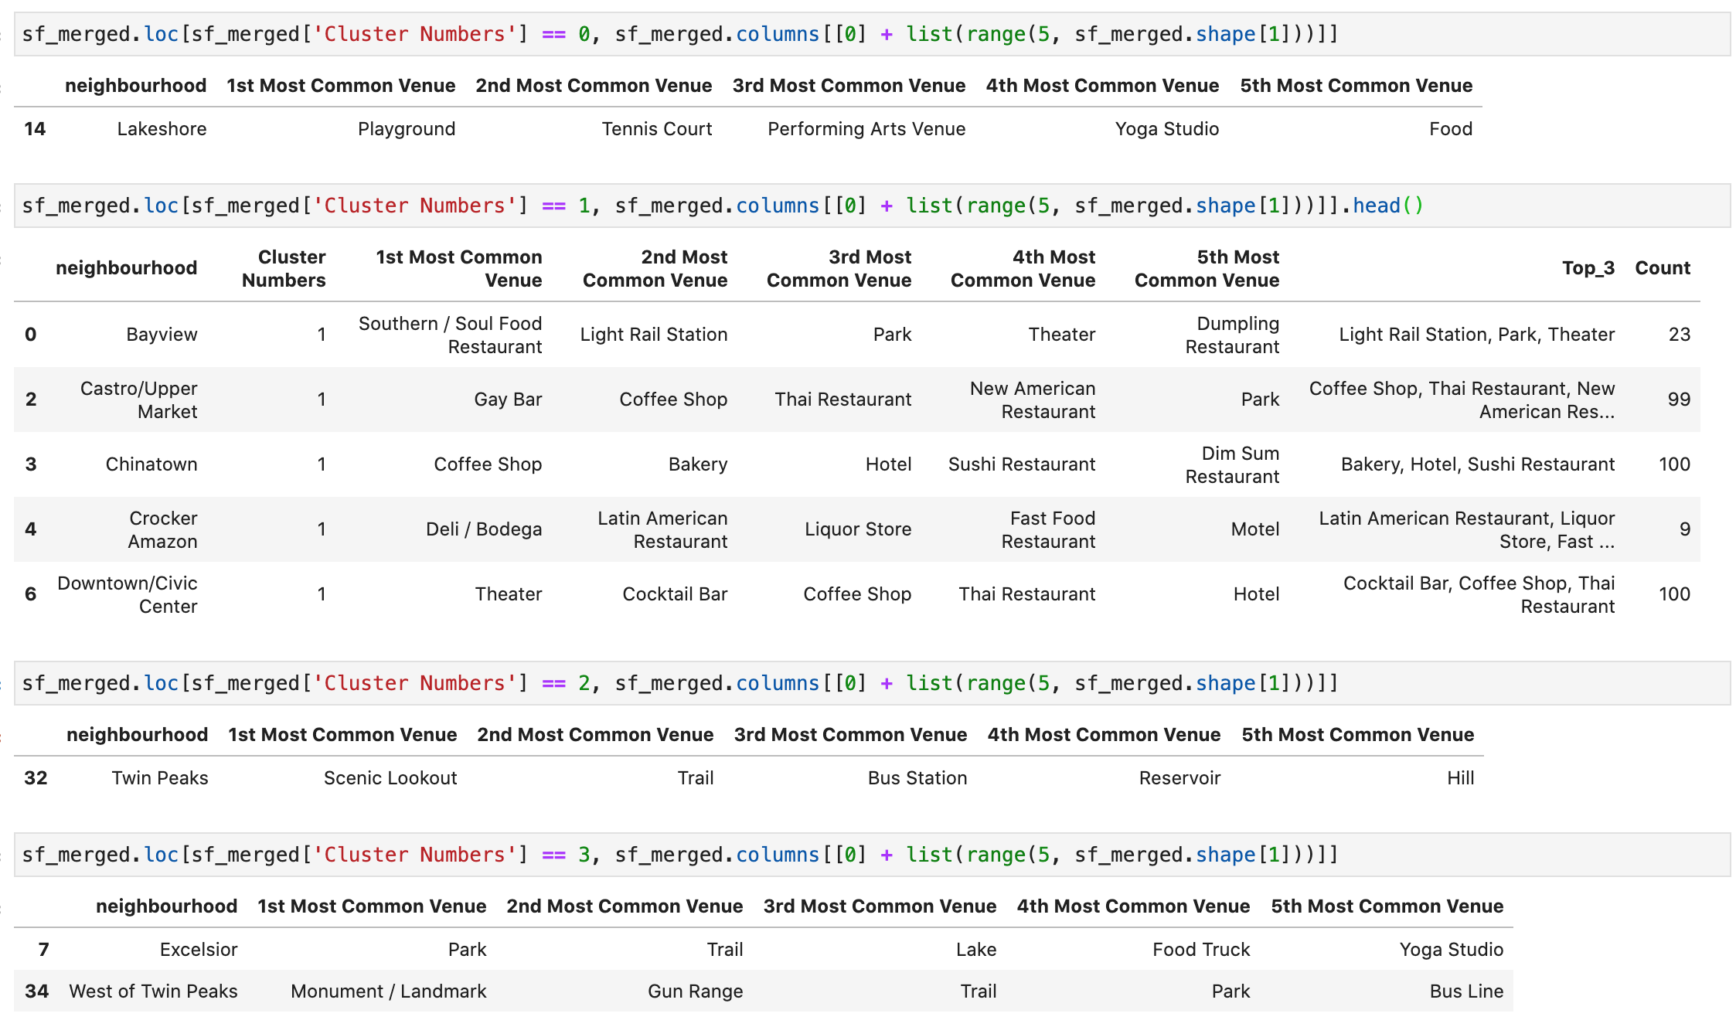

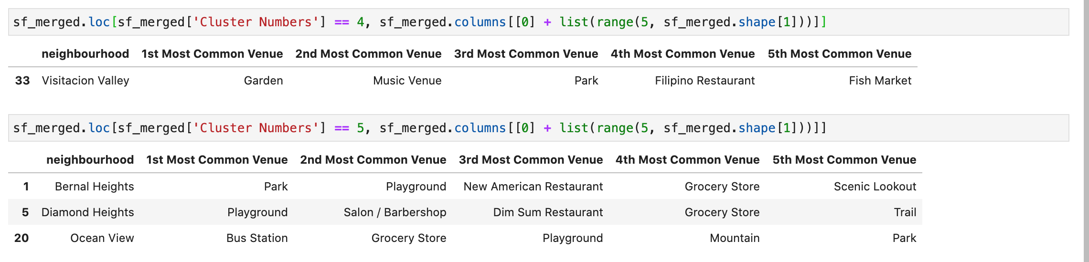

Fig 7. Data frames by cluster number for label naming.

The following labels were determined for all label numbers respectively: Leisure, Food and Drink, Trails and Hiking, Outdoor Leisure, Miscellaneous, Playgrounds and Essentials.

These labels were then inserted into the most common data frame, ready for mapping.

The map below displays the different clusters with labels showing the neighbourhood, the three most common venues in that neighbourhood and the number of venues in that neighbourhood.

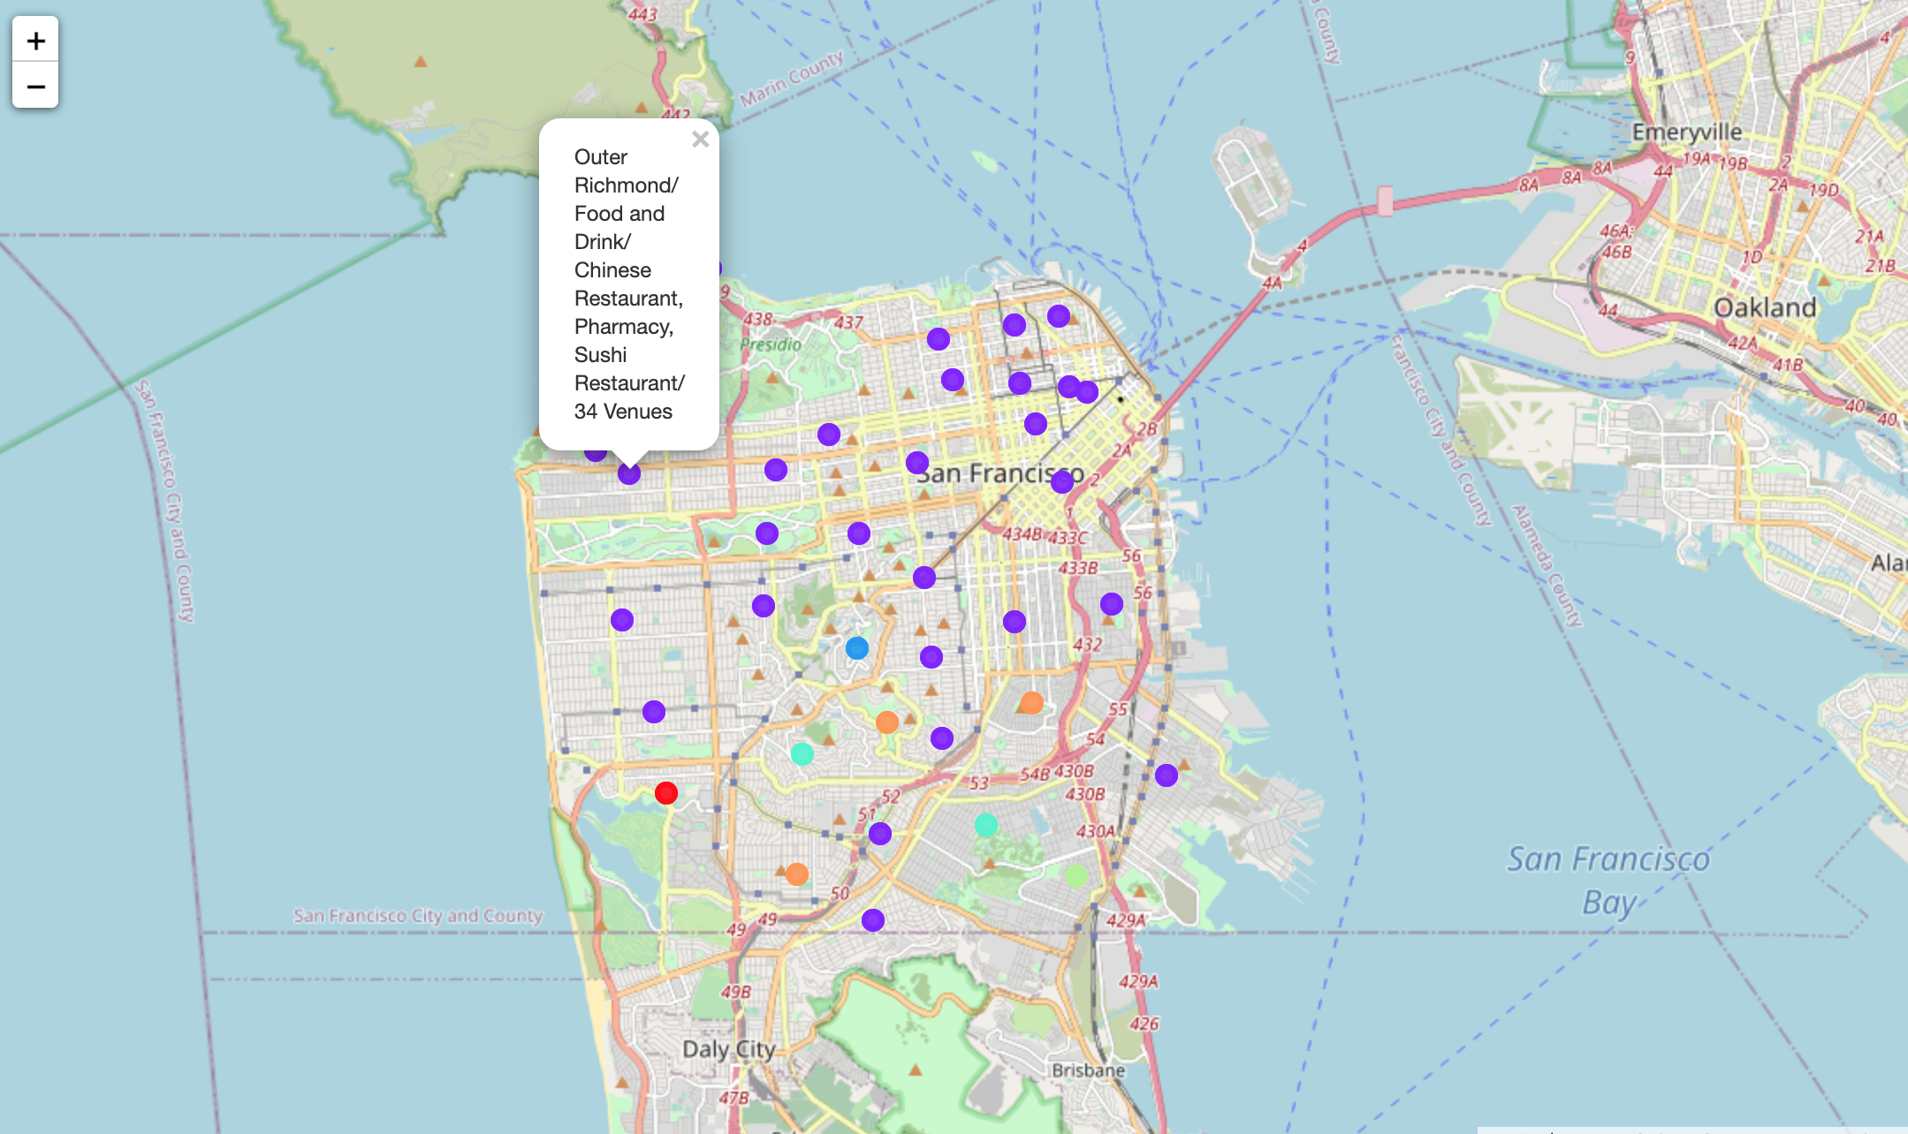

Fig 8. Map of San Francisco with cluster labels.

The next map has the same features as the map above, only this map is a choropleth underlaying the average Airbnb price with the cluster labels.

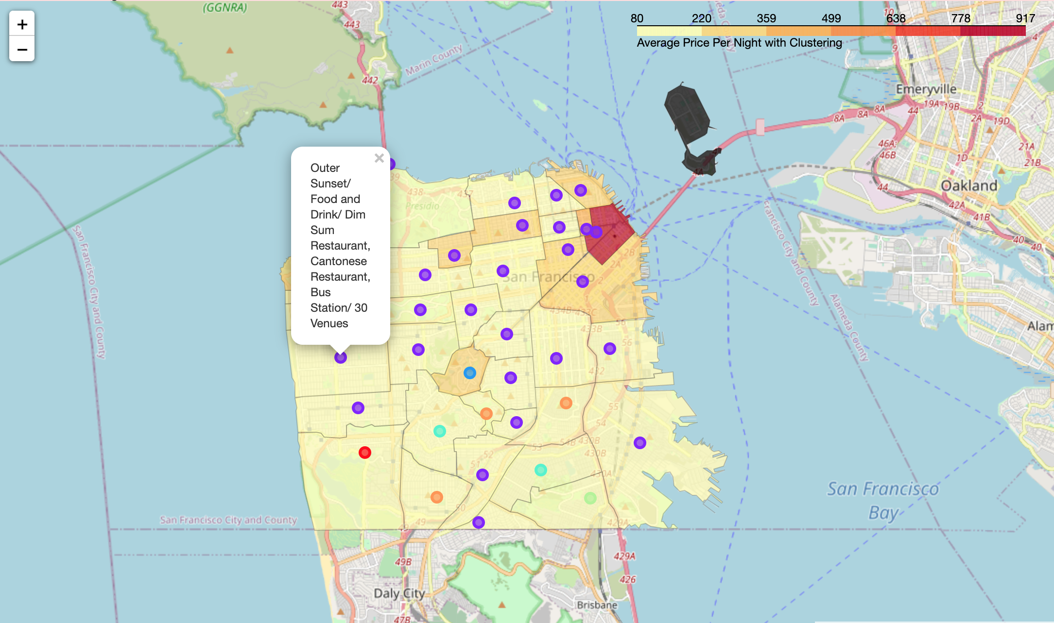

Fig 9. choropleth map of San Francisco with cluster labels and average Airbnb listing price.

1. **Discussion**

Airbnb listings and venue data are ever-changing, but analysis of the two together, no matter the location, can provide valuable insights to not only the customer but also those that list and those inside of Airbnb. San Francisco has always been known for its high cost of living and subsequently its high cost of travel, but many would say that you get what you pay for and that is made evident by the correlations between average neighbourhood Airbnb listing price and the amount of venues in that neighbourhood.

Venue clustering of common venues is useful information for travellers, especially when used in conjunction with price and venue density. San Francisco’s abundance of parks and trails outside of the city centre, make their respective neighbourhoods appealing but can also increase the price as is the case with the Seacliff and Pacific Heights neighbourhoods. This is also why the direct correlation between venue number and average Airbnb listing price is not stronger.

1. **Conclusion**

When it comes to travel preparation, the two main factors one must consider are price and location and this can take hours of research while running the risk of relying on outdated data and information. This study of up-to-date Airbnb listings and venue information of San Francisco provides travellers with the information to determine the above two factors with one click and a few scrolls, thus enhancing customer experience and listing efficiency.